|  |
| --- |
| PERVIOUS CONCRETE |
|  |
| MINI PROJECT REPORT |
|  |
|  |
| **F:\drive\photoshop\BITS_Pilani-Logo.svg.png** |

|  |
| --- |
|  |

**Divyanshu Shankar – 2014A2PS528P**

**Harsh Srivastava – 2014A2PS769P**

**Piyush Kumar – 2014A2PS782P**

**Prateek Arora – 20142APS556P**

**1. INTRODUCTION**

As we all know water is the biggest enemy of pavement. Persistent logging of rainwater on pavement surfaces result in potholes by inducing many pavement distresses and finally eroding it.

Secondly, the rapid urbanization involves rapid pavement construction using the conventional materials which is transforming the natural pervious ground into an impervious land cover. It results in lowering of water table and adversely affects the natural rainwater cycle.

Thirdly, the problem of storm-water management is quite serious in countries like USA and takes a heavy toll on govt. coffers and pockets of citizens. Cities are facing the challenge of increased runoff volumes, flash floods and increased failures of sewage systems. The impervious nature of the conventional pavement systems has resulted in increased storm-water runoff volume that has resulted in unacceptable level of pollutants, and unwarranted flash floods.

Unfavorable changes in the surrounding thermal environment like the creation of a difference in the temperature between urban and the surrounding rural areas is a big issue. The impervious pavement systems tend to act as heat storage media and release back the heat absorbed to the atmosphere during night. This phenomenon commonly called Urban Heat Islands (UHI) has led to discomfort for urban people, which has prompted the consumption of additional electricity for cooling purposes and increased CO2 emissions

The “thirsty concrete” or in technical terms pervious concrete is a panacea for all of the above challenges to environmentally sustainable and cost effective pavement development.

This topic of research is quite popular and has got a lot of attention. In this project we would discuss about the mix design, applicability and problems in usage of these materials with the help of research findings and online material available in this area.

**2. WHAT IS THIRSTY CONCRETE?**

Thirsty concrete is a kind of permeable pavement material. Permeable pavement materials simulate the natural pervious action of different lithospheric strata. Although pavement materials have been used for under pavement drainage for nearly 50 years, it was envisaged as a pavement construction material for the surface course quite recently. For example, Topmix Permeable, developed by Tarmac and Inflo, developed by Techblocs are fast draining concrete pavement solutions that rapidly directs storm-water off streets, parking surfaces, driveways and walkways. This type of concrete allows rainwater to percolate through its joints and in the way filtering it. It reduces the storm-water runoff and in turn helps reduce stress on storm water management systems. The water percolating inside replenishes the water table and can be used in terms of downfall instead of going off to ponds, lakes, rivers and other natural water reservoirs. These pavement materials have been successfully tested and employed as a sustainable and cost effective alternative in a variety of areas. These materials are developed to be used in a variety of areas and in harsh loading and environmental conditions. They resist ice build and thawing cycles and therefore reduces the need for deicing agents. Thirsty concrete is a simple to install pavement material and can be installed in a fast and cost effective manner. It is claimed to be durable and easy to maintain by its manufacturers. If these credentials are believed to be true, thirsty concrete is indeed a revolutionary pavement material.

**3. MIX DESIGN**

**Pervious concrete: materials, mix design, and mechanical properties**

Pervious concrete a gap-graded material having characteristic pore structure which comprises of interconnected, dead end, and capillary pores. The gradation of aggregates consisting of coarse aggregates, a binary mixture of coarse aggregates, sometimes in order to increase the strength of pervious concrete smaller size aggregates also used, these aggregates mixed with optimal amount of cement for coating and binding together. As mentioned by the National Ready Mix Concrete Association (NRMCA), for a typical pervious concrete range of the permeability varies from 15–25% with a minimum of 15%. Another important variable factor of the mix design water-to-cement ratio kept low as compared to mix design used in the conventional concrete mix, water to cement generally vary over the range of 0.28–0.40 keeping in mind to provide proper cement paste for sufficient coating of aggregates .Also, the aggregate-to-cement ratio varies in the range of 4:1 to as high as 6:1. Moreover, the volume of aggregates in pervious concrete is about 50–65% which is lower as compared to conventional concrete, having 60–75% amount of aggregates.

Aggregates

For maintaining sufficient amount of voids in the concrete, pervious concrete is usually made up of coarse aggregates ranging sizes from 19–9.5 mm. However, sometimes coarse having size of 9.5-2.36 mm used in the pervious concrete with aim to increase the strength of pervious concrete. The amount and proportion of aggregates used for various studies of pervious concrete shown below in Table 1. It is recommended that aggregates which has to be used in pervious concrete should have specific properties which provide specification limits, as gradation of aggregate will affect the properties which will affect pervious concrete pavement layers. For example, for materials such as clay, and chert their limits are mentioned, as they affect the bonding between cement paste and aggregates. The physical properties of aggregates which used in pervious concrete have to be similar to the properties of the aggregates used in conventional concrete.

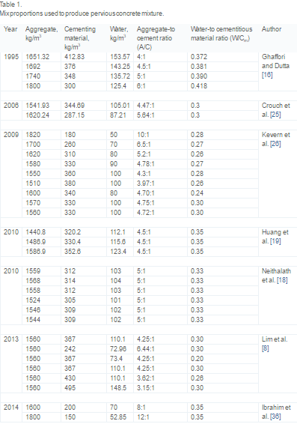

The physical characteristics of such as size, shape, and distribution have an important role in determining characteristics of pervious concrete pavements such as mechanical, durability, and permeability. Apart from the aggregate size, type of the aggregate plays a significant role on controlling the properties of pervious concrete. Though limestone aggregate has been used for the production of pervious concrete, however recent studies shows that dolomitic aggregates provides more strength to the pervious concrete.

However, demand of pervious concrete is becoming more because of its use for storm-water management in areas having freeze-thaw climates. The pervious concrete mixtures having granite aggregate showed superior resistance to F–T irrespective of any source/location. The mixtures of limestone and river gravel aggregates were observed to be easily damaged by F–T cycles. The aggregates properties such as abrasion resistance and water absorption played a crucial role in determining and controlling F–T damage, properties which controls water to easily permeate in pores of individual aggregates leads to the higher probability of F–T damage should be controlled and durability cracking in these pavements.

#### Cementing materials

The production of pervious concrete has been normally done using ordinary Portland cement (OPC) (Type-1) confirming to ASTM C150/C150M-15. The main use of the cementing material in the pervious concrete is to provide a sufficient coating and binding of the aggregates for increasing durability of pervious concrete. Other than using only Ordinary Portland Cement, researchers also used supplementary cementitious materials such as silica fume, fly ash as replacement for OPC. However, the results indicated that the effect of supplementary cementitious materials on pervious concrete not found similar to the observed in case of conventional concrete, and SCMs decreased strength properties of pervious concrete after a certain amount of SCM is used as partial replacement for OPC.

The thickness of the cementing material coating has been found as a very important factor in evaluating the hydrological and structural performance of pervious concrete pavements. It was determined using digital microscope that the paste thickness for pervious concrete consists of aggregates having different sizes, larger aggregates had thicker coating as compared to smaller aggregates had thinner coating, this is mainly due to the difference in surface area in the larger aggregates and smaller aggregates. The study also emphasized on the elastic modulus and compressive strength and it was found out with increasing size of aggregates, the compressive strength and elastic modulus increased.

Another recent study in 2015 focused on the method for determining thickness of cement paste in pervious concrete mixture. The study correlated strength and hydrological properties with the cement paste thickness. Evidently, with increasing paste thickness, the strength properties increased and porosity and permeability reduced. It was also observed with increasing thickness of cement paste there was decrease in strength properties of the pervious concrete. The comparison of cement paste thickness for two different studies shown in fig 2.

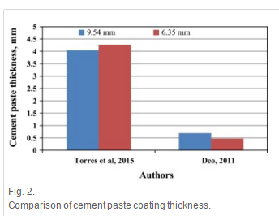

It is noted with increasing amount of cement content in pervious concrete, there may have been increase in the strength of the pervious concrete, but also increase in the thickness of the cement, which in turn reduces the pore properties such as porosity and permeability of the pervious concrete, which is the main purpose of pervious concrete.

#### Admixtures

The slump of the pervious concrete is usually zero, which necessitates the use of different admixtures to increase the workability of the pervious concrete without increasing the water content. For instance, retardation admixtures are used for easiness in the field placement which has been a problem since additional time required by the pervious concrete for placement and finishing owing to its harshness. Additionally, retarders are used to reduce the evaporation of water from the freshly laid surface, and air-entraining admixtures used to increase the durability against the F-T damage.

### Mix design and proportioning

The most common principle used for the mix design of pervious concrete is to provide enough cement coating on the aggregates surface. Nguyen et al developed a pervious concrete mix design and proportioning hypothesis based on the excess paste theory. The amount of cement paste volume required for sufficient coating of aggregates determined by dividing it with surface area of the spherical aggregates. The mix proportions used for investigations and designs by various researchers shown in [Table 1](http://www.sciencedirect.com/science/article/pii/S0950061816301131#t0005). As observed, density of aggregate varies in the range of 1400–1800 kg/m3 with range of aggregate to cement ratio of 4:1–12:1. Additionally, the water to cement ratio varied in the range of 0.2–0.42, and was in the lower range as compared to the conventional concrete

**4. MECHANICAL PROPERTIES**

Mechanical properties are important to be considered as they would consequently determine the pavement thickness and design life of pavement. The important mechanical properties which are usually studied are compressive strength, flexural strength, abrasion, fatigue life and resistance to freeze thaw cycles. The mechanical properties are as follows:-

**4.1 Strength Properties**

The strength properties pertinent to pervious concrete include compressive, flexure, and fatigue strength. The research in this area suggests that strength properties are function of mix variables, and are more sensitive to aggregate-to-cement ratio rather than water-to-cement ratio. The addition of materials like polymers and rubber increased the fracture toughness of the material due to an increase in the ductility. Owing to thin cement coating around the aggregates, the aggregate type has had a significant role in the strength development of pervious concrete.

The various studies indicated that curing period had no significant influence on flexural strength of pervious concrete. There were no significant differences between 7- and 28-day flexural strength. Further, the 7-day compressive strength of pervious concrete was found to be 70–90% of the 28-day compressive strength. This strength gain in 7-day was higher than that for the conventional concrete where 7-day strength is usually about 65–70% of the 28-day compressive strength. However, due to much larger quantity of aggregates in pervious concrete compared to that in conventional concrete, it is reasonable that there is no remarkable strength increasing at later ages. There is a difference in strengths when we consider high-strength supplementary cementitious material (SCM) modified pervious concrete (SPC) and polymer-intensified pervious concrete (PPC) which is of lower strength. The following image shows the different kinds of failure encountered in the two kinds of pervious concrete.

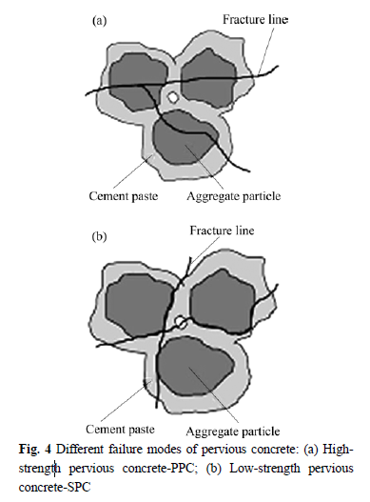

**4.2 Pore Properties**

The pore properties of pervious concrete are deemed to be equally important to the strength properties and thus play important role in characterizing the material as a sustainable pavement system. They are broadly divided into two categories-a) Transport related properties b) Non-transport related properties.

**4.2.1 Non-transport Related Properties**

Total porosity being one of main non-transport related properties is defined as the ratio of the volume of voids to the total volume of the sample . The total porosity/void content in pervious concrete is determined as per ASTM C1688. In pervious concrete, it was assumed that porosity remained constant along the depth but there exists vertical porosity distribution in pervious concrete Pores being random in size in a pervious concrete mix. The strength of pervious concrete decreased with increase in porosity. For example, in an experiment claimed that for porosities of 15%, 20% and 25%, the compressive strength magnitudes were in the range of 38–44, 29–35, and 15–22 MPa, respectively. This was an indication that strength decreased by approximately 50% for every 10% increase in the porosity.

**4.2.2 Transport Related Properties**

Transport related properties are those which actually help pervious concrete to function as an environmental-friendly pavement material. These properties transport water from surface to the bottom, and eventually aid in the recharge of ground water. The total porosity in the pervious concrete mix can be divided into interconnected pores, capillary pores, and dead-end pores . The interconnected pore skeleton which helps in the transportation of water is also referred to as effective porosity. Permeability has also been considered to study pore properties. Permeability being a function of aggregate size, compaction level, gradation and cement content was varied in the range of 0.1–2 cm/s.

**5. Mechanism of Thirsty Concrete**

The Thirsty Concrete is a new remarkable achievement of the building company ‘Tarmac’. It has the ability to drain the water from the surface to the groundwater table below and use it to recharge the groundwater. It has the capacity to drain 4000 liters of water in just a minute or 800 gallons in just 60 seconds. This value is way more than the normal concrete which is in use since ages. To achieve this exceptionally high rate of discharge or rate of drain there must be some different mechanism by which this percolation takes place.

Firstly, the top layer is made of paving layer of concrete mix which is very permeable. This permeability is achieved by using the concept of ‘No-Fines’ in the mix. Instead of using the traditionally used sand or similar fine aggregates in the mix, the tiny pieces of crushed granite is used. This provides quite high permeability in the mix. Below this is the different layers of the aggregates which not only allows drainage but also filtration of the draining water through the pavement layers. Water is mixed with oils, dirt, salt, and other impurities and while passing through the different layers of the concrete is filtered and such heterogeneous ingredients is filtered out thereby allowing clear water to recharge groundwater table. The absence of sand in the concrete in the mix ensures that there is no fine aggregates in the mix and hence no such materials that can fill the void created by the coarse aggregates and other stones stone fillings, thereby leaving the mixture full of voids and making it permeable. It is this void that the water in the later stage percolates through, and allows surface water run-off.

The different layers of the pavement can be broadly classified into six main layers which are concrete paving layers at the top, then followed by open-graded bedding course, then followed by open-graded base reservoir controlling discharge then comes last but third layer Open-graded sub-base reservoir, which is the thickest of all the layers not only ensuring the permeability but also the strength, then is the Geotextile layer which is optional to engineers constructing the pavement according to his need and then finally the last of all the layers which is un-compacted sub-grade soil characteristics of the given region of the soil. Each layer has its own role in letting the water discharge through the layers into the groundwater. Open-graded base and open-graded sub-base layer are made only of the coarse aggregate and hence are majorly responsible for the discharge of the water. The top layer rests on top of this and the voids within their plane of paving is filled with smaller coarse aggregate thereby ensuring the permeability of the concrete. The base and the sub-base becomes the reservoir. In the given figure is shown the cross-section of the ground surface which shows the detailed labelled diagram of the layers in the construction of the Thirsty Concrete.

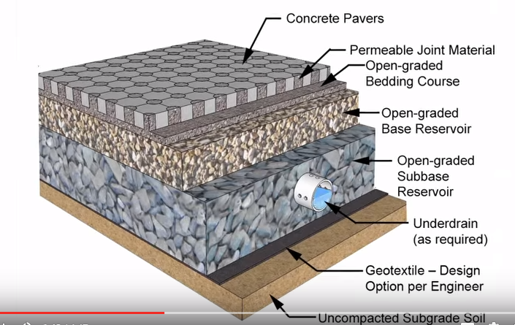

When the storm occurs or the rain water falls on the top surface of the mix the water percolates through the voids available in the top surface of the pavement and since there is no fine as such in the mix so it is completely porous and the water finds the path continuously till it reaches the groundwater. The permeability of this is quite high as can be shown by the picture below. As the water passes there is also the mechanism of water to store and discharge. Since the soil or the sub-grade has definite rate of water absorption and the Thirsty Concrete can discharge water at the rate of 4000 liters per minute against 300mm percolation of natural ground. In order to overcome this difficulty, there is the mechanism in which water flows through the pipe and is not allowed to get discharged immediately but stored in the reservoir. The pipe is made up of durable PVC material with some very fine openings called the ‘pore openings’. This mechanism is embedded in the open-graded sub-base mechanism and it acts as a reservoir. If there is a storm and the huge volume of water is percolating from the top surface but the sub-grade layer will not absorb with the same rate so in this case water will flow to open-grade and then to open-grade sub-base and then from there it will move into the pipe provided in that particular layer through the upper half surface of the pipe which is provided with relatively larger openings than that provided in its bottom.

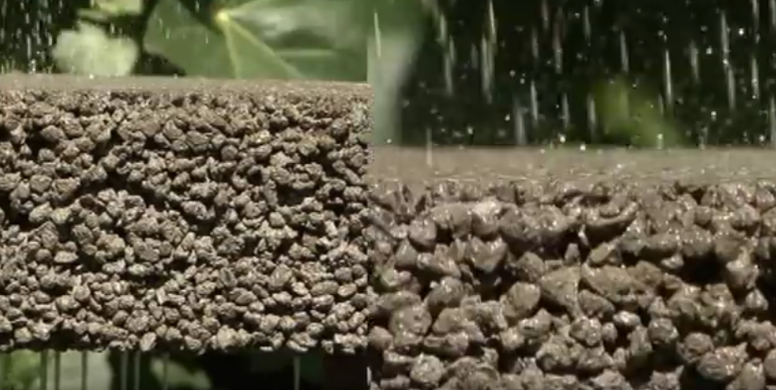

The water starts to store in it. It has lot of capacity to store and for days without degrading the quality of water. If the amount of water still exceeds the maximum quantity then that water is led through the bottom layer through the pipe joining in the form of Z shape. Thus the more amount of water the lower it gets allowing more space for inlet water to enter. This step-down takes place due to the pressure that incoming water creates in the pipe. Then as the period of storm gets over and the inlet percolation of water into the course layer ceases then still the mechanism works and the percolation of the water in the open-graded sub-base layer continues and the water percolates through the very small openings provided in the lower half surface of the pipe. It continues till all the water has percolated to the natural sub-grade.

The Top-mix company quotes its mechanism as “When rainwater falls on Top-mix, it drains through the porous concrete and a base layer of gravel, filtering out pollutants like motor oil in the process. Eventually, the rainwater percolates down into the ground, recharging natural aquifers. In times of intense rainfall, the process helps keep storm water infrastructure from becoming overwhelmed by effectively acting as a reservoir — pulling water out of the surface and into the ground, where it takes a while to seep back into the environment naturally.”

The main reason given by the company as justified is “As the world’s population continues to shift from rural to urban areas, natural drainage systems are being replaced with [impermeable surfaces](http://www.cnt.org/sites/default/files/publications/CNT_PrevalenceAndCostOfUrbanFlooding20141.pdf) — [mostly concrete](http://www.theatlantic.com/technology/archive/2014/09/portland-cement-changed-the-way-the-world-looked/380140/) — that hinder the environment’s ability to drain rainwater. In a forest, for instance, somewhere between [80 and 90 percent](http://www.aquatic.unesco.lodz.pl/index.php?p=water_cycle) of rainwater is absorbed back into the ground — in urban areas, that absorption can fall to just [10 percent](http://www.tarmac.com/media/492738/hydromediabrochure28pp_rebranded_lowres1.pdf) of rainwater. Humans have dealt with this by creating our own system of infrastructure — storm-water drainage systems and sewer systems — but much of this infrastructure is becoming increasingly outdated and unable to keep up with an increase in precipitation events linked to climate change.